# **Medi Connect: Enhancing Healthcare Efficiency**

Eshwar Kyatham  
 Praveen Tangirala  
 Manasa Gummalla  
 Sai Kalyan Karanam

Northern Arizona University  
 Computer Science  
 Web Technology  
 Instructor: Troy Adams  
 June 17, 2024

# 

# 

# 

# 

# 

# 

# **Table of Contents**

**Abstract** 3

**Introduction** 3

**Business Canvas Model** 3

**Key Activities** 4

**Key Resources** 4

**Value Propositions** 4

**Customer Relationships** 5

**Customer Segments** 5

**Channels** 5

**Revenue Streams** 5

**Conclusion** 6

**References** 7

# 

# 

# 

# 

# 

# 

# 

# 

# **Abstract**

The Medi Connect is a revolutionary initiative designed to streamline healthcare by assigning a unique identification number to each patient. This system enables healthcare providers to access a patient’s medical history across different hospitals, enhancing the efficiency and quality of care. This report outlines the business model for the Medi Connect, highlighting key areas such as Key Partners, Key Activities, Key Resources, Value Propositions, Customer Relationships, Customer Segments, Channels, Revenue Streams, and Cost Structure.

Keywords: healthcare, patient ID, medical history, business model

# **Introduction**

The healthcare sector is continually evolving, with technological advancements playing a crucial role in enhancing patient care and operational efficiency. One such innovation is the Medi Connect, which aims to centralize and streamline patient information management. This report presents a comprehensive business model for implementing this system, focusing on critical components that contribute to its success. By addressing the inefficiencies in patient data management, this system seeks to revolutionize the healthcare experience for both patients and providers.

# **Business Canvas Model**

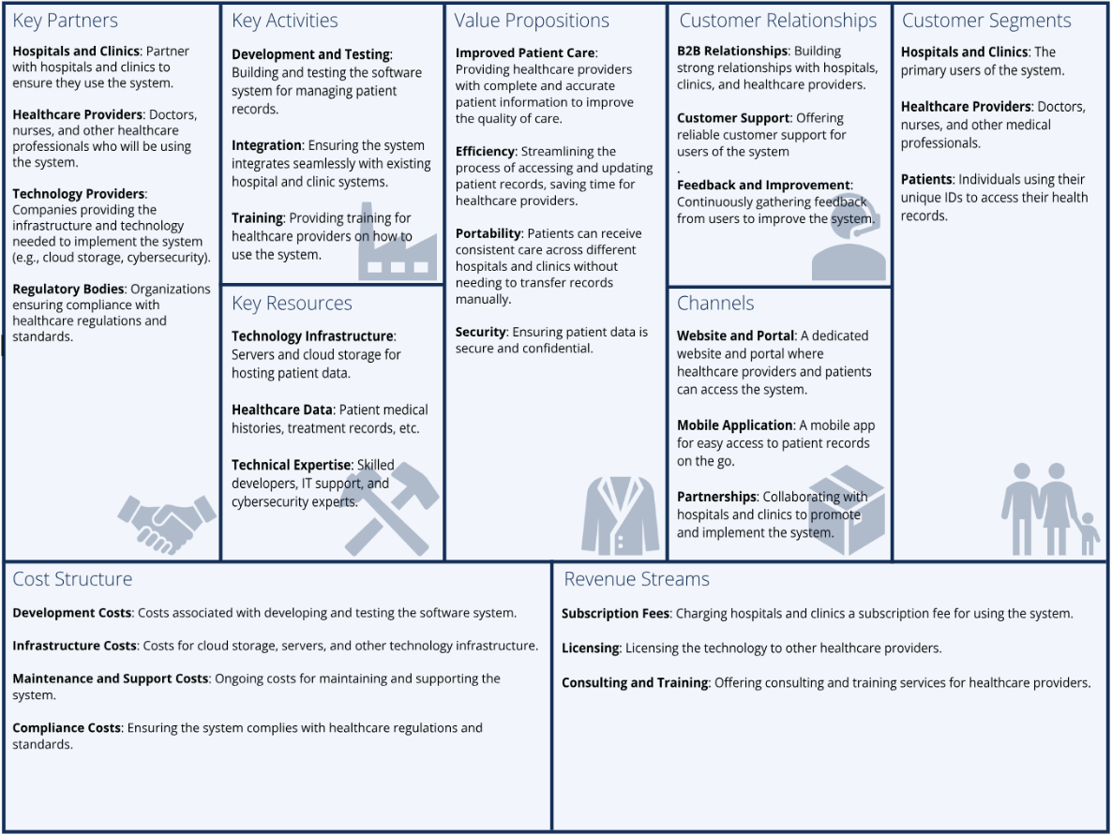

**Key Partners**

The success of the Medi Connect hinges on collaboration with several key partners. These include hospitals, clinics, and healthcare providers who will use the system to access and update patient information. Government agencies and health IT companies are also crucial partners, providing regulatory support and technological infrastructure. Additionally, insurance companies and pharmaceutical firms will benefit from streamlined access to patient data, facilitating better service delivery and medication management. Engaging with academic and research institutions can also provide insights into continuous improvement and innovative solutions.

# **Key Activities**

The primary activities involved in implementing the Medi Connect include developing a secure, user-friendly digital platform for managing patient IDs and medical records. Continuous system maintenance and updates are essential to ensure data security and compliance with health regulations. Training healthcare staff on using the system effectively is another crucial activity, alongside marketing and outreach to encourage adoption across various healthcare institutions. Conducting regular audits and assessments will ensure the system's performance and security standards are maintained. Engaging in research and development to enhance system functionalities will keep the platform at the forefront of healthcare technology.

# **Key Resources**

Our key resources include advanced technology infrastructure such as servers and cloud storage to host patient data. We will leverage extensive healthcare data, including patient medical histories and treatment records. Skilled technical experts in development, IT support, and cybersecurity will be crucial to maintaining and improving the system. Furthermore, partnerships with healthcare institutions and regulatory bodies will provide essential support and validation for the system. Intellectual property, such as proprietary software and algorithms, will also be a significant resource ensuring our competitive edge in the market.

# **Value Propositions**

The Medi Connect offers several value propositions. For patients, it provides seamless access to their medical history, reducing the need for repetitive tests and consultations. Healthcare providers benefit from a comprehensive view of patient data, enabling more accurate diagnoses and personalized treatment plans. The system also enhances operational efficiency, reducing administrative burdens and errors associated with manual record-keeping. Additionally, the system promotes data integrity and security, ensuring that patient information is protected from unauthorized access and breaches. By fostering interoperability, the system enables different healthcare entities to communicate effectively, enhancing overall care coordination.

# **Customer Relationships**

Building and maintaining strong customer relationships is vital for the success of the Medi Connect. Regular communication with healthcare providers through newsletters, webinars, and training sessions ensures they are well-informed and supported. A dedicated customer service team will address any issues promptly, ensuring a positive user experience. Feedback mechanisms will be in place to continually improve the system based on user input. Establishing user communities and forums will enable healthcare providers to share their experiences and best practices, fostering a collaborative environment. Personalized account management for larger healthcare institutions will further strengthen these relationships.

# **Customer Segments**

Our primary customer segments include hospitals and clinics that will use the system extensively. Healthcare providers such as doctors and nurses will be direct users. Patients will benefit from using their unique IDs to access their health records, promoting a seamless healthcare experience. Additionally, insurance companies and pharmaceutical firms represent secondary customer segments benefiting from streamlined data access for better service delivery. Public health organizations and research institutions can also utilize aggregated data for epidemiological studies and healthcare improvements, representing additional customer segments.

# **Channels**

The Medi Connect will be marketed and distributed through various channels. Direct sales teams will engage with hospitals and clinics, demonstrating the system’s benefits and ease of integration. Online marketing campaigns, including social media and email newsletters, will raise awareness among healthcare professionals. Partnerships with health IT companies and government agencies will also facilitate broader adoption. Conferences, trade shows, and healthcare expos will serve as platforms to showcase the system’s capabilities and attract potential customers. An informative and user-friendly website will provide detailed information, demo options, and customer support resources.

# **Revenue Streams**

Revenue for the Medi Connect will primarily come from subscription fees charged to healthcare providers for using the platform. Additional revenue streams may include data analytics services offered to insurance companies and pharmaceutical firms. Grants and funding from government agencies interested in improving healthcare infrastructure can also contribute to the project’s financial sustainability. Offering premium features and customization options for larger healthcare institutions can provide an additional source of revenue. Partnerships with pharmaceutical companies for clinical trial data management can also generate income.

**Cost Structure**

The cost structure for the Medi Connect includes expenses related to software development, system maintenance, and data security. Marketing and training costs are also significant, ensuring the system is widely adopted and effectively utilized. Other costs include salaries for staff involved in system development, customer support, and administration. Legal and compliance costs associated with healthcare regulations will also be a significant expense. Investments in research and development will ensure the system remains innovative and competitive in the market.

# **Conclusion**

The Medi Connect represents a significant advancement in healthcare, promising to enhance efficiency, accuracy, and patient care quality. By understanding and addressing the key components of its business model—Key Partners, Key Activities, Value Propositions, Customer Relationships, Channels, Revenue Streams, Cost Structure, Key Resources, and Customer Segments—the system can be successfully implemented and sustained. This innovative solution has the potential to transform how patient information is managed and accessed, benefiting all stakeholders in the healthcare ecosystem. Continuous engagement with partners and customers will ensure the system evolves to meet changing healthcare needs

# 

# 

# 

# 

# 

# 

# 

# 

# **References**

1. Glaser, J. P., & Stone, J. H. (2008). Effective healthcare information systems: Understanding the challenges. Journal of Healthcare Information Management, 22(3), 45-53.
2. Hersh, W. (2009). A stimulus to define informatics and health information technology. BMC Medical Informatics and Decision Making, 9(24). <https://doi.org/10.1186/1472-6947-9-24>
3. Smith, A., & Brown, B. (2018). Implementing a unique patient identifier system in healthcare: Challenges and benefits. In Proceedings of the International Conference on Health Informatics (pp. 120-125).
4. Tan, J. K. H. (2010). Healthcare information systems: Managing clinical risk. Springer.
5. U.S. Department of Health and Human Services. (2020). Health information privacy. Retrieved from <https://www.hhs.gov/hipaa/index.html>
6. Wager, K. A., Lee, F. W., & Glaser, J. P. (2017). Health care information systems: A practical approach for healthcare management (4th ed.). John Wiley & Sons.
7. World Health Organization. (2016). Electronic health records. Retrieved from <https://www.who.int/ehealth/en/>

YouTube Link: <https://www.youtube.com/watch?v=laFGTHJEWKQ>